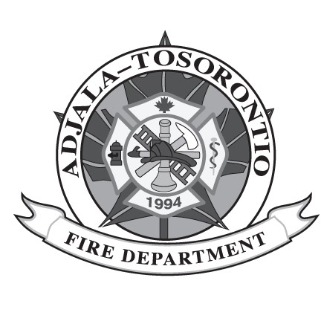
Volunteer / Paid On-Call Firefighter Application Form

Personal information on this form is collected under the authority of the
Municipal Freedom of Information & Protection of Privacy Act and will be used to
determine eligibility for employment as a Volunteer / Paid On-Call Firefighter. Questions about this collection of information should be directed to Human Resources at HR@adjtos.ca or 705-434-5055.

Contact Information

Last Name: | First Name:
Home Address:

Phone Number: | Email:

Eligibility Requirements
I am 18 years of age or older:
[ ] Yes / No [ ]
I have an Ontario Secondary School Diploma or academic equivalent:
[ ] Yes / No [ ]
I am legally eligible to work in Canada:
[ ] Yes / No [ ]
I can provide a clean Vulnerable Sector Check if hired:
[ ] Yes / No [ ]
I possess a valid Class G Driver’s Licence:
[ ] Yes / No [ ]
I can provide a clean Driver’s Abstract upon hire:
[ ] Yes / No [ ]
I am willing to obtain DZ Driver’s Licence within 2 years of hire date:
[ ] Yes / No [ ]
I reside within 8 KMs of Station 1 (6234 County Rd 13, Everett) or Station 2 (2821 Regional Rd 50, Loretto):
[ ] Yes / No [ ]

I possess valid Ontario Fire Administrative Inc. (OFAI) Stage 1 – Firefighter Aptitude & Character Test (FACT) and Stage 3 – Firefighter Physical Aptitude Job-Related Tests (FPAT):
[ ] Yes / No [ ]
I am available to respond to emergency calls:

Weekdays: [ ] Often [ ] Sometimes [ ] Never

Weeknights: [ ] Often [ ] Sometimes [ ] Never

Weekends: [ ] Often [ ] Sometimes [ ] Never

I acknowledge that I have read and understand the 2025 Recruitment Guide:

[ ] Yes / No [ ]
Preferred Qualifications

I have previous firefighting experience with a fire department:
[ ] Yes / No [ ]
I have completed NFPA 1072 Hazardous Materials Awareness & Operations and NFPA 1001 Firefighter Level 1 & 2 certification:
[ ] Yes / No [ ]
I possess a valid Standard First Aid CPR-C + AED certificate:
[ ] Yes / No [ ]
I possess a valid Class DZ Driver’s Licence or equivalent:
[ ] Yes / No [ ]
Conditions of Acceptance

I hereby declare that the information given is true and complete to my knowledge. I understand that any false statements, misrepresentation, deliberate omission or concealment of information may disqualify me from employment or cause my dismissal:

[ ] Agree

Applicant Signature: | Date:

Township of Adjala-Tosorontio is an Equal Opportunity Employer, committed to diversity and inclusivity in employment for a barrier-free workplace. Accommodations are available for all parts of the recruitment, selection &/or assessment process. Applicants need to make their needs known in advance to Human Resources. We thank all those who apply, but only those selected for an interview will be contacted.

